Dhiman Gurumanie Singh  
Professor Murphy  
Engl 314  
25 May 2024

**Beginner's Guide to Bouldering**

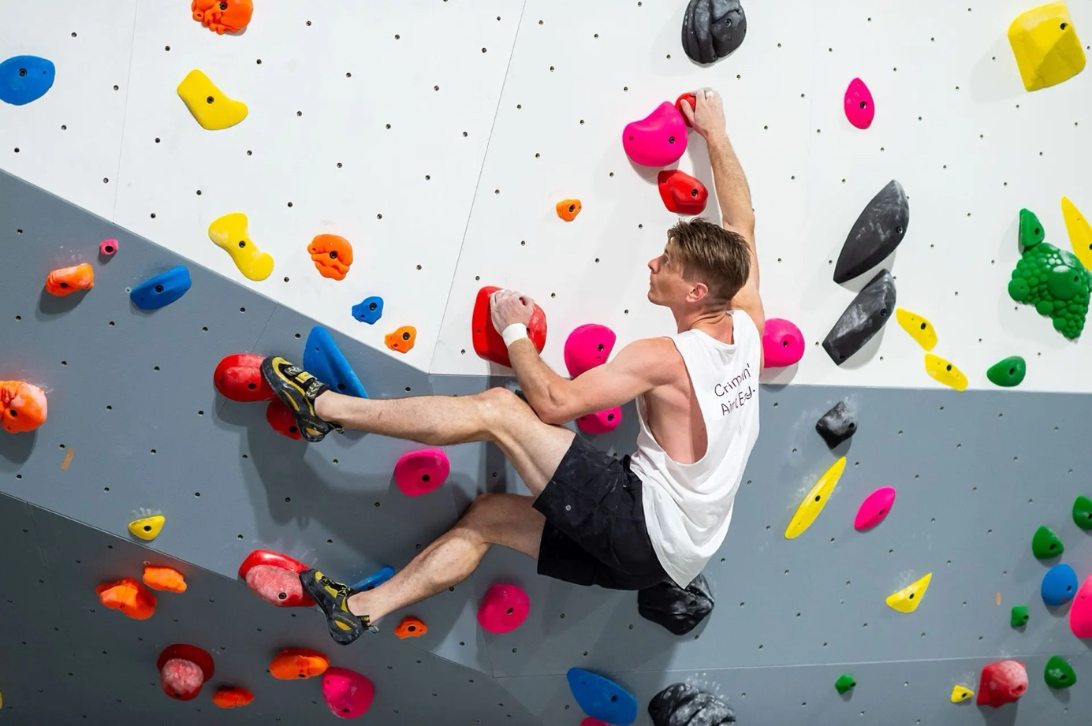

Footholds

Handholds

**Figure 1**: Bouldering wall with an experienced climber

This guide is intended for individuals who are new to bouldering, a form of rock climbing done on small rock formations or artificial rock walls without the use of ropes or harnesses as shown above in **Figure 1**.

The guide also aims to provide a comprehensive introduction to the basics of bouldering, including types of holds, basic movements, common bouldering problems, necessary equipment, and safety tips.

**Table of Contents**

1. Introduction to Bouldering
   1. What are the benefits of Bouldering?
2. Essential Equipment
   1. Climbing Shoes
   2. Chalk and Chalk Bag
   3. Crash Pad
3. Types of Hand Holds / Foot Holds
   1. Jugs
   2. Crimpers
   3. Slopers
   4. Pinches
   5. Foot Holds
4. Basic Movements
   1. Dynamic Movements
   2. Static Movements
   3. Mantling
5. Common Bouldering Problems
6. Safety Tips and Best Practices

**1. Introduction to Bouldering**

**Craving a challenge that tests your strength, technique, and problem-solving skills? Look no further than bouldering!** This popular and accessible form of rock climbing focuses on completing short, intricate sequences of moves known as "problems." As a beginner, you will embark on a journey of discovery, learning to navigate a diverse range of handholds, footholds and mastering movements to succeed in these bouldering challenges.

1. What are the benefits of Bouldering?

Bouldering offers a surprising range of fitness benefits that go beyond the perception of a simple activity due to its short walls and rest periods. While short climbs and breaks may seem relaxing, bouldering provides one of the most effective full-body workouts available. It combines both anaerobic and aerobic elements, making it a strong alternative to traditional weight training and a great way to improve overall fitness.

So, if we were to look at the significant benefits, then these are the highlights:

* **Strength Training:** Bouldering is a full-body workout that engages major muscle groups. Your core is constantly activated, your upper body works through a full range of motion, and even your legs get a push. Since you're using your own body weight, it's a fantastic calisthenics option for efficient strength gains.
* **Mental Focus:** Unlike traditional weight training, bouldering requires intense concentration. You're constantly planning your next move, ensuring proper body positioning, and making critical decisions – making it a mentally stimulating exercise.
* **Grip Strength and Forearm Health:** With the constant use of computers, many of us have weakened forearms and poor grip strength. Bouldering specifically targets these areas, helping to prevent issues like carpal tunnel syndrome and forearm cramping.
* **Improved Stamina:** While primarily a power and strength workout, bouldering also improves your endurance. The longer you climb, the more your anaerobic threshold is pushed, leading to better cardiovascular health and overall stamina. The effort required to maintain your body position and maneuver yourself translates to significant stamina gains after just a few sessions.
* **Problem-Solving Skills:** Bouldering is a constant mental puzzle. You're always strategizing the best route, planning next moves, and figuring out how to reach your goal. This quick thinking and decision-making develop your problem-solving skills in a unique way.
* **Social and Fun Experience:** Bouldering is a social activity enjoyed with like-minded people. Climbing gyms often foster a sense of community, with people watching, offering tips, and helping each other out, making it a fun and engaging experience.

**2. Essential Equipment**

Ensure you have the necessary equipment listed in **Table 1** before bouldering.

|  |  |
| --- | --- |
| Equipment | Description |
| Climbing Shoes | Provide grip and precision |
| Chalk and Bag | Keep hands dry and improve grip |
| Crash Pad | Cushions falls and prevents injuries |

**Table 1**: Equipment list for beginner bouldering.

1. Climbing Shoes

*Climbing shoes offer better grip and precision. Beginners should choose snug, comfortable shoes. See* ***Table 2*** *below for details:*

|  |  |  |
| --- | --- | --- |
| Neutral (Beginners) | Moderate (Advanced) | Aggressive (Expert) |
| how to choose a climbing shoe chart | how to choose a climbing shoe chart | how to choose a climbing shoe chart |
| No Downturn* | Slight Downturn* | Strong Downturn* |
| Symmetrical Shape | Fairly Symmetrical Shape | Asymmetrical Shape |
| Stiff Sole | Medium Stiff Sole | Soft Sole |
| Comfortable Tight Fit | Tight Fit | Uncomfortable Tight Fit |
| Toes Flat | Toes Slightly Curved | Toes Curled |
| Durable | Medium Durable | Fast wear |

**Table 2**: Climbing shoes provide grip and precision.

*\*Downturn indicated by yellow curve*

(<https://www.improve-climbing.com/choose-climbing-shoes-beginner/>)

1. Chalk and Chalk Bag

*Chalk helps keep your hands dry and improves grip. Use a chalk bag to carry the chalk while climbing. Both items go hand in hand as shown below in* ***Figure 2****.*

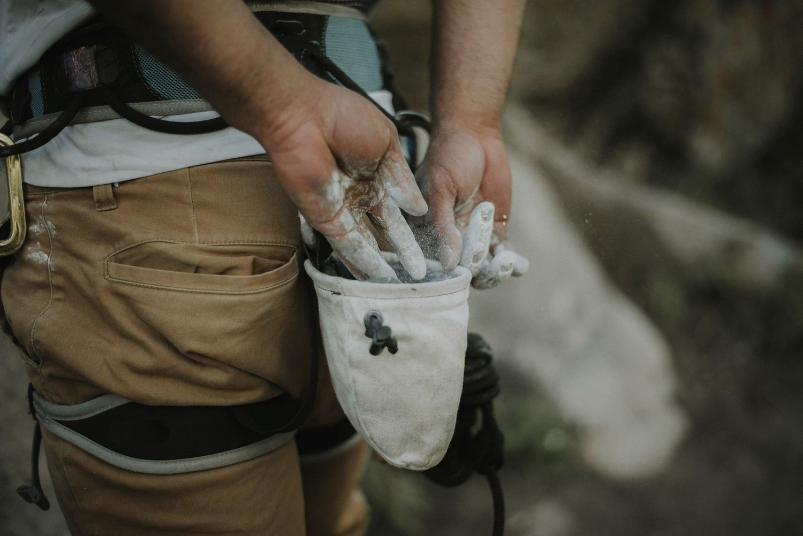

Chalk Ball

**Figure 2**: Chalk and a chalk bag help keep hands dry.

(<https://www.tripsavvy.com/best-chalk-bags-4175226>)

1. Crash Pad

*A crash pad, shown in* ***Figure 3****, is a thick foam mat placed on the ground to cushion falls and prevent injuries.*

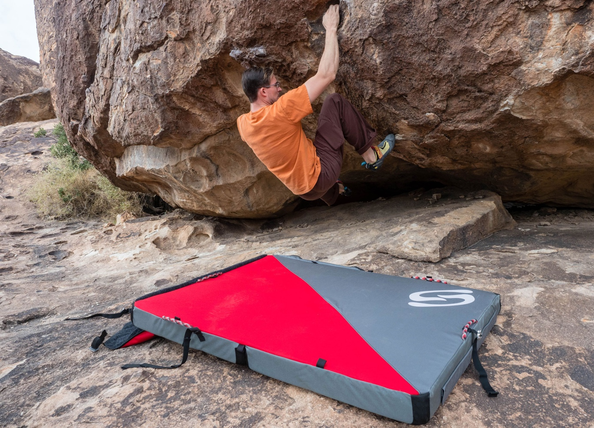

**Figure 3**: Crash pad for safe landings.

*Areas marked in red are danger zones

(<https://gearjunkie.com/climbing/bouldering/send-climbing-3x4-pro-bouldering-crash-pad-review>)

**3. Types of Hand Holds**

Understanding different types of handholds is crucial for effective climbing. Here are some common holds you'll encounter:

1. Jugs

*Large and easy-to-hold, jugs are excellent handholds for beginners, as shown in* ***Figure 4****.*

**Figure 4**: Example of a jug hold.

1. Crimpers

*Crimpers, shown in* ***Figure 5****, demand a sturdy grip and significant finger strength due to their small size.*

**Figure 5**: Example of a crimp hold.

1. Slopers

***Figure 6*** *shows that Slopers are rounded holds that rely on friction and an open-handed grip.*

**Figure 6**: Example of a sloper hold.

1. Pinches

*Pinches, as shown in* ***Figure 7****, are held onto by pinching them in between your thumb and fingers.*

**Figure 7**: Example of a pinch hold.

1. Foot Holds

*Foot Holds, as illustrated in* ***Figure 8****, are the small supports on a climbing wall or rock where you place your feet.*

**Figure 8**: Example of a foot hold.

**4. Basic Movements**

Bouldering involves both dynamic and static movements. Understanding these movements will help you climb more efficiently.

1. Dynamic Movements

*Dynamic movements involve using momentum to reach the next hold. This requires coordination and timing as shown in* ***Figure 9*** *below.*

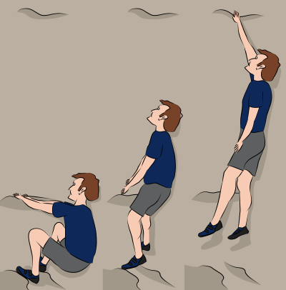

**Figure 9**: Example of a dynamic movement.

1. Static Movements

*Static movements, showcased in* ***Figure 10****, involve deliberate and controlled motions to move from one hold to another, demanding both balance and strength.*

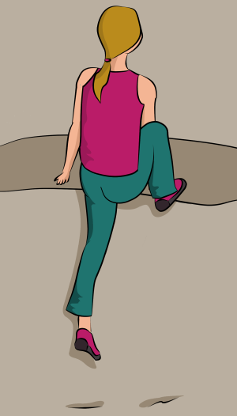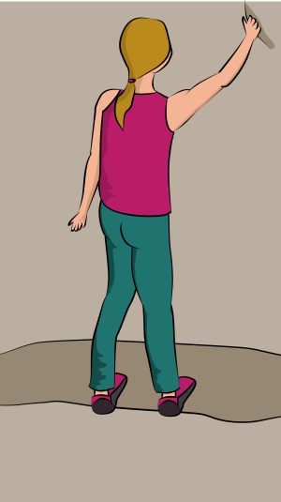

**Figure 10**: Example of a static movement.

1. Mantling

*Shown in* ***Figure 11****, mantling is the action of shifting your weight over a hold by pushing down on it, like the motion of getting out of a swimming pool.*

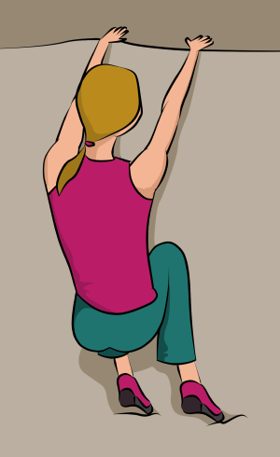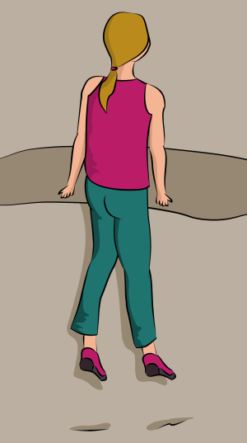

**Figure 11**: Example of mantling.

**5. Common Bouldering Problems**

Bouldering involves many of the same challenges as other forms of climbing, though some are encountered more often in bouldering:

**Faces and slabs:** *A face is a flat vertical surface, and a slab is a flat angled surface. Both problems test technical skill and require delicate footwork.*

**Overhangs:** *Also called "roofs," these are rock surfaces that are relatively horizontal to the ground and directly over your head. Overhangs demand strength and power*.

**Traverses:** *Often an endurance test for boulderers, these problems involve moving sideways along a feature in the rock before topping out.*

**Compression problems:** *Requiring good endurance and solid technique, these problems frequently require the climber to "hug" a feature on the rock to ascend the boulder.*

**Highballs:** *A term unique to bouldering, a highball is any problem that tops out high off the ground. It might put a climber 20 feet or more off the ground, though it's really about the degree of exposure and risk presented. This is the realm of experienced boulderers.*

**Topping out:** *The final part of most bouldering problems, this refers to the final series of moves required to get you standing on the top.*

**6. Safety Tips and Best Practices**

Bouldering can be physically demanding and sometimes risky. Follow these safety tips to ensure a safe climbing experience:

* + **Warm Up**: *Always warm up before climbing to prevent injuries. Shown below in* ***Figure 12*** *are some of the various warm up.*
  + **Start Slow***: Begin with easier problems and gradually progress.*
  + **Use a Spotter**: *Climb with a partner who can spot you and guide your fall.*
  + **Check Your Landing Area***: Ensure the crash pad is properly placed and free of obstacles.*
  + **Listen to Your Body**: *Take breaks and stay hydrated. Do not push yourself beyond your limits.*

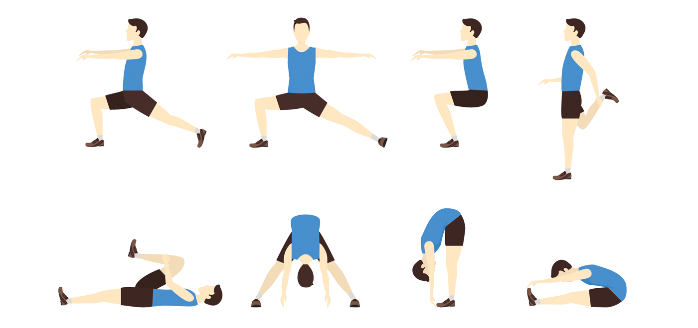

Hip warm up:

Leg warm up:

**Figure 12**: Always warm up before starting to climb.

By following these steps and practicing regularly, you'll develop the skills and confidence needed to enjoy bouldering safely and effectively. Happy climbing!

**References:**

“Bouldering for Beginners.” *Climb Fit*, 13 Jan. 2022, www.climbfit.com.au/bouldering-for-beginners/.

“How to Boulder: Bouldering Basics: Rei Co-Op.” *REI*, REI, www.rei.com/learn/expert-advice/bouldering.html. Accessed 30 May 2024.

*Amazon.Com: Atomik Climbing Holds*, www.amazon.com/stores/AtomikClimbingHolds/Homepage/page/D2289F59-9910-4545-885D-B67BBF5853D3. Accessed 30 May 2024.

VDiff. “Climbing Techniques: Moving on Rock - Sport Climbing Skills - Vdiff Climbing.” *VDiff*, 30 July 2023, www.vdiffclimbing.com/sport-technique-movement/.

Fischer-Colbrie, Megan. “The Importance of Warm up and Cool down for Athletes.” *BridgeAthletic Blog*, BridgeAthletic, 24 July 2017, blog.bridgeathletic.com/the-importance-of-warm-up-and-cool-down-for-athletes.